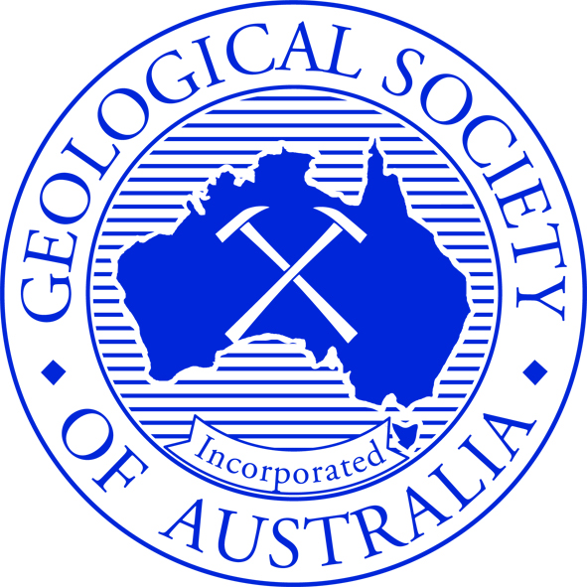

GEOLOGICAL SOCIETY OF AUSTRALIA,
VICTORIA DIVISION
Annual General Meeting
Thursday 18th April 2024 at 6.15pm
Location: Fritz Loewe Theatre, McCoy Building, cnr. Swanston and Elgin streets, University of Melbourne, Carlton VIC

Agenda
- Welcome and Apologies
- Minutes of Previous Meeting
- Reports from the Chair
- Audited Financial Reports (Balance Sheet and Profit & Loss for 2023)

Reports Attached Below:
Report from the Secretary
Report from the Treasurer
Report from the Membership Secretary/Convenor
Report from the Talks/Programme Sub-Committee Secretary/Convenor
Report from the Social Media Sub-Committee Convenor
Report from the Geoheritage Sub-Committee Convenor
Report from the Geotourism Sub-Committee Convenor
Report from the Awards Sub- Sub-Committee Convenor
Report from the Education Sub-Committee Secretary/Convenor

- Nomination of incoming Committee Positions:
Chair
Vice Chair
Secretary
Treasurer

Subcommittee Representatives:
Awards
Heritage
Education
Newsletter
Social Media
Membership
Website

Committee Members:
(Speaker Program)
(Investments)
(University of Melbourne Student Representative)
(Monash University Student Representative)

- Voting / endorsement of incoming Committee Positions

Note: Only financial members of the GSA can hold office in a Committee position, vote, endorse or nominate.

- Proxies
- Any other business
- Meeting close

Attachments

Secretary Report: GSAV Annual Report 2024

GEOLOGICAL SOCIETY OF AUSTRALIA,
VICTORIA DIVISION
Annual General Report
(Report to the Governing Council April 11th 2024)

Names of the committee for 2023-2024 announced at the AGM on 25th May 2023

Chair Anne-Marie Tosolini
Vice Chair David Cantrill
Secretary Ashleigh Hood
Treasurer Oskar Lindenmayer

Subcommittee Representatives
Awards John Webb
Heritage Susan White
Education James Driscoll
Newsletter Ashleigh Hood
Social Media Emily Finch
Membership Ashleigh Hood
Website Ashleigh Hood/Stefan Vollgger

Committee Members
Dee Ninis (Speaker Program)
Rick Squire (Investments)
James La Greca (University of Melbourne Student Representative)
Rory McNab (Monash University Student Representative)

Chairs Report

Welcome to all our members of the Geological Society of Australia, Victoria Division, for 2024, including renewing members and new members who have joined over the past year. We would like to acknowledge the Traditional Owners of this land, the people of the Kulin Nations, and pay our respect to their Elders, past and present. We uphold and acknowledge their continuing relationship to this land.

I was honoured to be elected as the new Chair at the GSAV AGM in May, 2023. Over the past year, I was privileged to work with both our new representatives on the Committee, Ashleigh Hood, Oskar Lindenmayer, Emily Finch, James La Greca (UniMelb student rep.) and Rory McNab (Monash student rep.), and our longer-standing representatives, David Cantrill, Susan White, Dee Ninis, Rick Squire, James Driscoll and John Webb. We had a great meeting and dinner with the federal Geological Society of Australia Committee in December, organised by GSA Chair, Amber Jarrett.

We have had several representatives stand down recently and I would like to thank them for their time and effort over several to many years: David Moore, as President (2004-2005) and on the awards committee, Sam Boone of the awards committee, and Stefan Vollgger as long serving webmaster.

Our highlights of 2023 included the outstanding Selwyn Symposium, in September 2023. This was organised by Ashleigh Hood, with international speaker A/Prof Alan Rooney and five Australian geologists, who brought broad and diverse approaches and insights into geological time. This enjoyable event was a great platform for geological discussions, poster sessions, sharing ideas and networking and was followed by a social dinner.

Our interesting seminar series, organised by Dee Ninis, included the Howitt Lecture on Antarctic Ice Sheets by Professor Andrew Mackintosh and Dr Jessica Hamilton on the Synchrotron. Our student night in August, 2023, was a success thanks to high calibre student talks by Mana Ryuba and James La Greca. GSAV awards from 2020 to 2023 were handed out a little late, due to COVID interruptions. We had an amazing tour of the Melbourne Museum mineral and fossil collections, thanks to Oskar Lindenmayer and Rolf Schmidt. Sue White gave a talk on Geoheritage for our end of year function to summarise the work done in this important aspect of GSAV.

I would like to congratulate our 2024 Selwyn Medal Awardee Dr Kevin Hill and second year student Jonathan Purcell for the Frank Canavan Award. A new Diversity and Inclusion element has been added to grants to encourage broader appeal to all our members and guide the committee when choosing applicants.

Education events were held by James Driscoll and Emily Rochette at the Science Teachers’ Australia Victoria Conference, Geography Teachers’ Conference and other important outreach events. Finally, thanks are due to the Finance Committee, Oskar Lindenmayer, Rick Squire and David Cantrill for taking care of the shares portfolio and successfully managing the GSAV finances for 2023.

We look forward to further activities and work on the committee in 2024.

Dr Anne-Marie Tosolini

Treasurers Report

GSA Victoria Treasurer Report to Committee for 18th April 2024 Annual General Meeting

NAB Account Activity: (1st January to 30th December 2023)

Bank balance as of 1st January 2022: $37,058.79
Bank balance as of 31st December 2022: $11,951.43
Change: -$25,107.36

Deposits made to the account in the above period: $4,704.32

Which comprises the following categories:
GSAV Capitation Credits for 2022 membership: $2,217.68
Refund of unused sponsorship TESEP $1,500.00
Selwyn Symposium Tickets $551.28
Copyright Agency $335.36
Book sales: $100.00
TOTAL $4,704.32

Funds paid out of the account in the above period: $29,811.68

Which comprises the following categories:
A. Production of 10 Thomas Medals $8,767.00
B. Production of 10 Selwyn Medals $8,679.00
C. Running Selwyn Symposium $3,230.77
D. Production of 4 Granite Plinths (for Selwyn Medals) $2,704.44
E. National Storage Fees $1,668.00
F. Sponsorship of TESEP booth (refunded) $1,500.00
G. Updating Honour Board $605.00
H. Monthly meetings (room booking + food and drinks) $552.01
I. Engraving and postage of awarded medals $524.48
J. Sponsorship of CAVEPS Conference $500.00
K. Student travel grant (first half of one $700.00 grant) $ 350.00
L. PO Box rental $338.00
M. Website hosting $272.98
N. Bank account fees: $120.00
TOTAL: $29,811.68

COMMENTS
- A large portion of funds spent in 2023 ($20,674.92) went towards production of medals and plinths. This large upfront cost will reduce costs in future years.
- No Postgrad Awards were awarded in 2023, and only half of the one Student Travel Award awarded was paid out. These programs are expected to resume in 2024 as a large expense.
- During 2023 the GSA Vic committed to providing $3,382.60 towards development of school lending kits of rocks and minerals, and related educational resources. This will be paid out during 2024.

Oskar Lindenmayer (Treasurer)
9th April 2024

Investments Report

The investment portfolio achieved a strong gain (post all fees and costs) of about 10.2% in 2023. The result was largely driven by uplifts in the Australian and international shares, especially in the December quarter when the portfolio gained about 5.8%.
In 2023, total assets increased in value from $613,608.91 to $676,443.79. No money was distributed to the central committee via tax receipts from franking credits (payments for FY2023 are anticipated in mid-2024) and there was no inflow of capital into the portfolio in 2023. To 31 December 2023, the portfolio generated a return (post all fees and costs) of about 5.0% p.a. over 3 years and 8.8% p.a. over 5 years. Therefore, the portfolio is achieving its aim of generating a return of >5% above CPI over a rolling 5-year period.

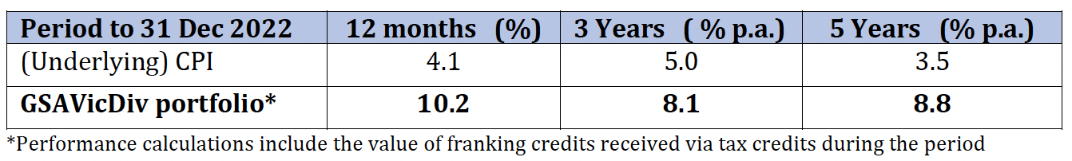

Performance in 2023 was achieved from a combination of gains in several of the large positions, dividend returns and minor tactical trading. The only changes to the portfolio were exits in Scentre Group, Stockland Group and Vicinity Centres, and buying APA Group and RAM Essential Services Property Fund.

In FY2023, the portfolio generated $6,169.32 in franking credits. This will be returned to the central committee mid-2024 when tax receipts are received.

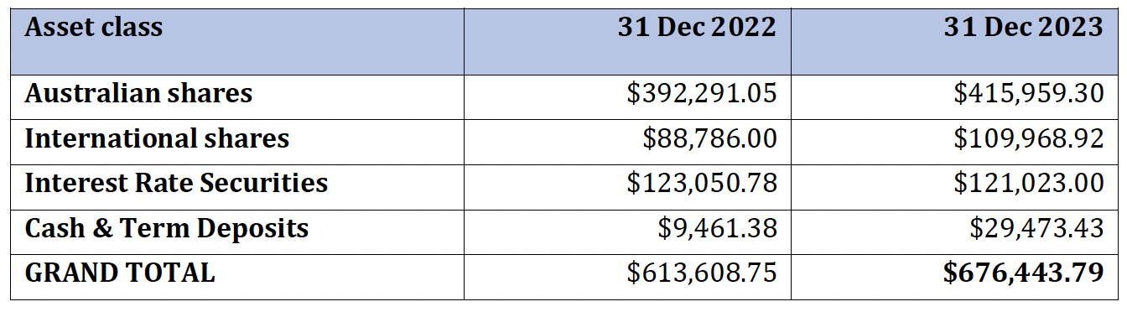

At the end of 2023, the portfolio held $415,959.30 in Australian shares, $109,968.92 in international shares, $121,023.00 in interest-rate securities and $29,473.43 in cash and term deposits.

The executive committee has agreed to merge the Vic Div investment portfolio with the portfolio managed by the federal division. Evans & Partners (currently used by the Vic Div) will manage the newly combined portfolio. The two portfolios should be merged in about April 2024.

Rick Squire

Meetings

Geological Society of Australia - Victoria Division: Presenters & Seminars - 2023-2024

27 April
Juliet Sefton (Monash Uni) “Mangrove sediments as geological archives for reconstructing Holocene sea level”

25 May
Laurent Ailleres (Monash Uni) “Loop - an interoperable, integrative, probabilistic 3D geological modelling platform”

22 June
RSV / GSAV Howitt Lecture 2023
Andrew Mackintosh (Monash Uni) “Glaciers and ice sheets in a warming world”
27 July
Jessica Hamilton (ANSTO) “Earth and Environmental Science at the Australian Synchrotron”

31 August
GSAV Awards Ceremony
Mana Ryuba (Uni Melb) “Synsedimentary breccias in the Teena Dolomite: evidence of extensional Tectonics in the Proterozoic McArthur Basin”
James La Greca (Uni Melb) “Earthquake environmental effects and Bayesian analysis of ground motion models using chimney fragility curves, 2021 Mw 5.9 Woods Point earthquake, southeast Victoria, Australia”

28 September
Selwyn Symposium - Geological Time: Old Rocks, New Ideas

26 October
Oskar Lindenmayer (Museums Victoria) & Rolf Schmidt (Museums Victoria) - Melbourne Museum Collection Tour

23 November
Susan White (GSA Vic.) “Geology's place in the natural history of Victoria; Sites of Geological Significance, Geoheritage and Geotourism”

December
-

January
-

29 February
Karen Chin (Uni. Colorado) “An Arctic marine ecosystem in the greenhouse world of the Late Cretaceous"

21 March
Kevin Hill (Uni Melb) “Structure and tectonics of Cape Liptrap; some myths and new analyses"

Events

Selwyn Symposium 28th September 2023 “Geological Time: Old rocks, New Ideas”

The theme of this symposium was geological time. The Earth has a complex history of over 4.5 billion years of geological time. Many aspects of geological research hinge on having a well-defined chronology, but dating the rock record is far from simple. In this symposium, presenters consider old rocks with new insights, and cover a range of different time scales from the recent past to the ancient Earth. Questions around the timing of past climate change, biotic evolution and crustal processes are the focus of the discussion. The emphasis of some talks will be on new ideas and techniques in geochronology–refining how we establish the precise timing of ancient processes. Speakers will show us through geological time from the Precambrian right through to the last glacial maximum. The talks cover a range of archives from igneous and sedimentary rocks, through to fossils and caves.

Thanks to everyone who made the Selwyn Symposium 2023 a success!
We had around 60 people at the Selwyn Symposium on the 28th September, in the Fritz Loewe Theatre, University of Melbourne. We heard some fantastic talks by all our speakers:
Dr. Ellen Corrick, Monash University
Dr. Richard Selwyn-Jones, Monash University
Dr. Vera Korasidis, University of Melbourne
Assoc. Prof. Oliver Nebel, Monash University
Heidi Allen, Geological Survey of Western Australia (DMIRS)
That evening, the Selwyn Public Lecture was given by Assistant Prof. Alan Rooney from Yale University. Alan took us through "The Timing and Tempo of Glaciations and the Rise of Complex Life", including some great science, as well as amazing field photos and stories.
Special thanks to Malcolm Wallace, Nik McMillan, Elowen Amos, Oskar Lindenmayer and Susan White for helping the event run so smoothly
Ashleigh Hood

Awards Report

The Awards committee is pleased to present the following report on the 2023-2024 Awards:
- THE SELWYN MEDAL
Alfred Richard Cecil Selwyn (1824-1902), British geologist and founding Director of the Geological Survey of Victoria and pioneer of the early geological mapping of the State.

2023 SELWYN MEDAL was awarded to Kevin Hill

Nomination by Mike Hall
Kevin is a graduate of Oxford University (BA), the University of Alberta, Canada (MSc), and has a PhD from the University of Melbourne. While much of his work has been involved with industry, particularly in Papua New Guinea, he has also made a significant and valuable contribution to Victorian geology and has been responsible for training students and practising geoscientists in understanding sedimentary basins.
As a staff member of La Trobe University, and later the University of Melbourne, he established a 3D seismic-structural workstation laboratory, conducted research in the modelling of tectonics and complex structures and introduced numerous students to the use of advanced technology in working in sedimentary basins. This also involved the application of apatite fission track and U-Th-He thermochronology. In addition to teaching, Kevin has supervised students at all levels, including PhD.
Kevin’s work in southern Victoria’s sedimentary basins, together with his supervision of some outstanding PhD students, has led to a more rigorous understanding of how they evolved through several complex events. In the Otway Basin, while examining the transition from rifting to seafloor spreading, he introduced the concept of section balancing and the effects of basement inheritance to understand the Mesozoic history, and showed how the geometry had been modified by later compressional events, leading to structural inversion. In addition, he showed how vitrinite reflectance and fission track thermochronology could be used to estimate the petroleum prospectivity of the region.
Similar work in the Bass Basin highlighted the importance of structural inversion and the necessity of integrating thermochronology into any study of basin prospectivity.
Kevin’s work in the Gippsland Basin also focussed on the tectonic and structural evolution. He used 2D section balancing and 3D structural modelling to show how inheritance played a significant role as the evolving structures were influenced by stress rotation, overprinting and compressional reactivation. He also showed how the filling history of the basin was influenced by these events.
By studying small scale structures at Cape Liptrap, Kevin showed that these could be used as analogues in understanding the geometry and development of large-scale fold and thrust belts. These observations proved highly successful in understanding the Papua New Guinea fold and thrust belt, where Kevin also supervised a PhD student who was able to relate the structural development to major earthquakes, a commonly under-rated aspect in the study of many fold and thrust belts.
Another significant contribution over many years is Kevin’s continuing leadership and development of the popular VIEPS Sedimentary Basin field course for post-graduate students and professional geoscientists, based on classic Otway Basin outcrops along the Great Ocean Road.
In addition to the above activities, Kevin has been a PESA Australia distinguished lecturer and was editor of an Eastern Australian Basins conference volume.
Nomination by Eleanor Green and Ashleigh Hood
Kevin has made an exceptional contribution to geoscience teaching and research in Victoria. Kevin is an outstanding geoscientist, with many years of experience within industry, consulting and academia. While we briefly list some highlights of his career, we wish in this letter to focus on his generous and sustained support for students and junior colleagues at the University of Melbourne and elsewhere.
Kevin has a well-established and successful career as a geologist in industry and academia. Much of his work integrates new technology and techniques to study the evolution of sedimentary basins and fold belts in Australia and elsewhere. He uses structural geology, seismic interpretation, tectonic modelling, geochemistry, stratigraphy, 3D modelling and a broad range of other geological techniques to interpret sedimentary basins and their resource potential. Kevin’s career spans several continents, and he has held prominent positions at a range of companies and consultancies including BP and Oil Search. In terms of teaching, Kevin has lectured at La Trobe University and is currently an Honorary Associate Professor at the University of Melbourne. He has led a variety of industry short courses and fieldtrips, including recently for the AAPG. In other Victorian roles, he has been a committee member at the Victorian branch of PESA, and a Distinguished Lecturer for PESA Australia.
Through student supervision and his own research, Kevin has made important contributions to our understanding of the geology of the Victorian sedimentary basins, and has also focused on the complex geology of Papua New Guinea. In some brief examples of his contributions to geological knowledge, his work has added to our understanding of: the Mesozoic to recent tectonic history of the southern margin of Australia; the importance of integrating thermochronology and thermal maturation work into basin perspectivity; the complex and active tectonic history of PNG; the role of basement and structural inheritance in basin evolution; and many studies using regional seismic and structural modelling to unravel the complex depositional and inversion history of the Victorian basins. While many pages of text could be written on Kevin’s important research contributions to Victorian geology, in every role and research project that Kevin has undertaken, his commitment to teaching and mentorship are exemplary, and deserve to be highlighted.
Kevin's approach to teaching is typified in two VIEPS courses that he has taught for many years: Sedimentary Basins and Resource Analysis and Basin Structure and Stratigraphy. Frequently rewritten and refreshed, and featuring logistically complex field trips, these courses consume much annual time and effort. This is however amply repaid by the enthusiastic reception from the graduate students. While Kevin must be pleased with the exceptionally positive student feedback, he is still more pleased with a thoughtful response from a student to a challenging question – he is dedicated to helping Victorian students become fully fledged geoscientists.
Through his role as a graduate research supervisor, Kevin has inspired many more students with his habit of rigorous thinking and his love of field geology. Kevin is an exemplary graduate supervisor: he is deeply expert in his specialism of structural geology, yet curious and enthusiastic about every other aspect of geoscience; he pushes students to become capable independent researchers, yet is sensitive to the challenges that they may face. Most recently he has supervised several field-based projects along his beloved Gippsland coast. We should mention the kindness and generosity of his wife Kathy, who herself has a longstanding dedication to the geosciences, in facilitating the many weekends of fieldwork entailed in Kevin’s supervisory roles. Kevin’s warmth and generous spirit make him not only a fine teacher but also an outstanding colleague. In particular, he goes out of his way to provide opportunities for junior staff, and pushes for recognition of their work. Collaboration or co-supervision with Kevin is an invigorating experience, that is sure to be imbued with Kevin’s love for Victoria and his deep understanding of Victorian geology.
We wholeheartedly recommend Kevin Hill as a GSAV Selwyn Medallist.

2023-2024 GSAV STUDENT AWARDS
The 2024 FRANK CANAVAN AWARD for the most promising second year geology student in Victoria was awarded to Johnathan Purcell from University of Melbourne. Johnathan achieved >90 in the 2 second year subjects he completed in 2023 and was the top student in each by some margin.
The D. E. THOMAS MEDAL - no award was made this year, because no thesis nominated had a sufficiently substantial field mapping component.
I am very grateful for the continuing support of the committee comprising David Moore and Sam Boone.
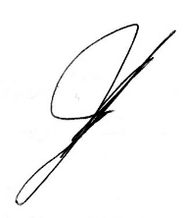
John Webb, Chair, GSAV Awards Committee
28 March 2024

Education Report

Over the past year we have continued to reinvigorate the Education Subcommittee with a focus on the Earth and space science component of the Science 7–10 Victorian Curriculum in terms of both content delivery and PD for teachers.
The GSA(V) Committee accepted a proposal to place the Monash Mineral and Rock Lending Library (now renamed the Mineral and Rock Lending Library - MRLL) under their auspices as a GSA(V) outreach initiative asset, and a further three MRLL kits are being developed for 2024 using some of the La Trobe University (LTU) teaching collection (John Webb has kindly donated a swag of teaching samples from this LTU collection).
James Driscoll and Emily Rochette presented workshops at the Science Teachers’ Association of Victoria (STAV), Geography Teachers’ Association of Victoria (GTAV) and the Laboratory Technicians’ Association of Victoria) (LABCON) conferences, focusing on providing out-of-field high school teachers with geoscience teaching resources, and the confidence, to teach the rock cycle (Levels 7 & 8), plate tectonics (Levels 9 & 10), VCE Environmental Science and VCE Geography. James and Emily have also been developing teaching resources and lesson plans will complement the MRLL – this will include video resources that act as a PD session for the high school teaching community.
James and Emily have also initiated dialogue with the Royal Society of Victoria and Mappa to investigate running joint geoscience-focused field trips in 2024. James is already leading similar field trips for Geography Victoria and GTAV.
Finally, the new Rock Garden and the revamped interior of the Volcanoes Discovery Centre (VDC) in Penshurst will officially open in late Autumn 2024. James continues to work with the Southern Grampians Shire Council and the VDC Committee to provide a geoscience outreach program to high schools in southwestern Victoria.
James Driscoll

Social Media Report
GSA Victoria maintains an X (formerly Twitter) account as its sole social media platform. The @GSAVictoria X account has 1467 followers and follows 2163 accounts.

Over the period from the last AGM (25 May 2023) until 9 April 2024 there have been 65 posts or reposts from the GSA Victoria account. Over this period, the highest number of views on an original @GSAVictoria post was 1.6k for a post advertising the Selwyn Symposium on 26 September 2023.

Emily Finch

Geological Heritage Report

This report of from April to December 2023 as the Federal reporting has changed. Material prior to April is found in the 2023 Report. Very little has occurred since December. This report is very similar to the one I supplied to the Federal Standing committee in January 2024.

GSA(V) continues maintain a data base of sites of Geological Significance for Victoria as no state government department has undertaken this since the late 1990s. We have excellent co-operation from the Geological Survey of Victoria (GSV) and the Victorian Environmental Assessment Council (VEAC). The legacy online site information of consultant reports from the 1980s and 1990s is not maintained and does present some problems as the significance statements are often seriously out of date.

There over 2000 sites listed in the database and new sites have been continued to be identified over this past 10 months. We are still in the process of updating the data base.
Again, there have been limited issues raised. Most importantly has been co-operation with VEAC in making sure that its reports have up to date with respect to geological heritage sites. VEAC in particular has a state-wide remit on all government and Crown land, and the GSA(V) Heritage Subcommittee is working closely with their project officers, especially with regard to the assessment of native forest areas e.g. the recent Central Highlands RFA.
Other site enquiries were related to development matters and consultants (especially windfarms). This is a service that we can provide to consultants at very little effort.

I continue to be a member of the DEECA Committee of Management (COM) of the Council Trench Geological Reserve at Bacchus Marsh. The COM organised a local display and activity for Earth Science Week based on the grasslands of the area and their relation to the geology. The November 2023 Division meeting was a presentation of the work of the subcommittee that was well received.

Interest in appropriate use of the data base for geotourism sites continues but slowly. Involvement in the Australian Geoscience Council’s (AGC) National Geotourism Strategy Working Groups (WG 4 & 5) have taken up time I would prefer to use to deal with geological heritage matters.

The subcommittee remains very small and I thank those members of GSA and others who have helped this year. I have approached a few people regarding being involved but have had only limited success so far.

Susan White

Geotourism Report

No actual subcommittee exists for Geotourism, and the Geological Heritage Subcommittee deals with anything of significance, despite it not being core business. Anyone who is interested in volunteering in this space, please contact Susan White.

Very limited involvement has occurred although I have represented the Victoria Division where appropriate.

Involvement in the Australian Geoscience Council’s (AGC) National Geotourism Strategy Working Groups (WG 4 & 5). I have attended Zoom meetings for these working groups when possible. The main interest the AGC’s WG have is access to our Heritage sites data base but as not all sites are suitable for tourism, access to the entire data base has not been provided. Tourism agencies in Victoria have not directly approached GSA(V) for information.

Susan White

